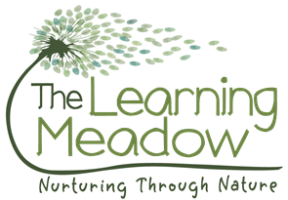
10.11 Working in partnership with other agencies

Policy statement
Here, at The Learning Meadow, we work in partnership with local and national agencies to promote the well-being of all children. We will never share your data with any organisation to use for their own purposes.

Procedures

- We work in partnership, or in tandem, with local and national agencies to promote the well-being of children.
- We have procedures in place for the sharing of information about children and families with other agencies. These are set out in our Privacy Notice, Information Sharing Policy, Safeguarding Children and Child Protection Policy and the Supporting Children with Special Educational Needs Policy.
- Information shared by other agencies with us is regarded as third-party information. This is also kept in confidence and not shared without consent from that agency.
- When working in partnership with staff from other agencies, we make those individuals welcome in our setting and respect their professional roles.
- We follow the protocols for working with agencies, for example on child protection.
- We ensure that staff from other agencies do not have unsupervised access to the child they are visiting in the setting and do not have access to any other child(ren) during their visit.
- Our staff do not casually share information or seek informal advice about any named child/family.
- When necessary, we consult with and signpost to local and national agencies who offer a wealth of advice and information that help us to develop our understanding of the issues facing us and who can provide support and information for parents. For example, ethnic/cultural organisations, drug/alcohol agencies, welfare rights advisors or organisations promoting childcare and education, or adult education.

This policy was adopted by | The Learning Meadow | (name of provider)
On | October 2018 | (date)
Date to be reviewed | October 2019 | Thereafter annually
Signed on behalf of the provider
Name of signatory | Dawn Pirie
Role of signatory (e.g. chair, director or owner) | Owner/manager

